Traffic light – Entrance
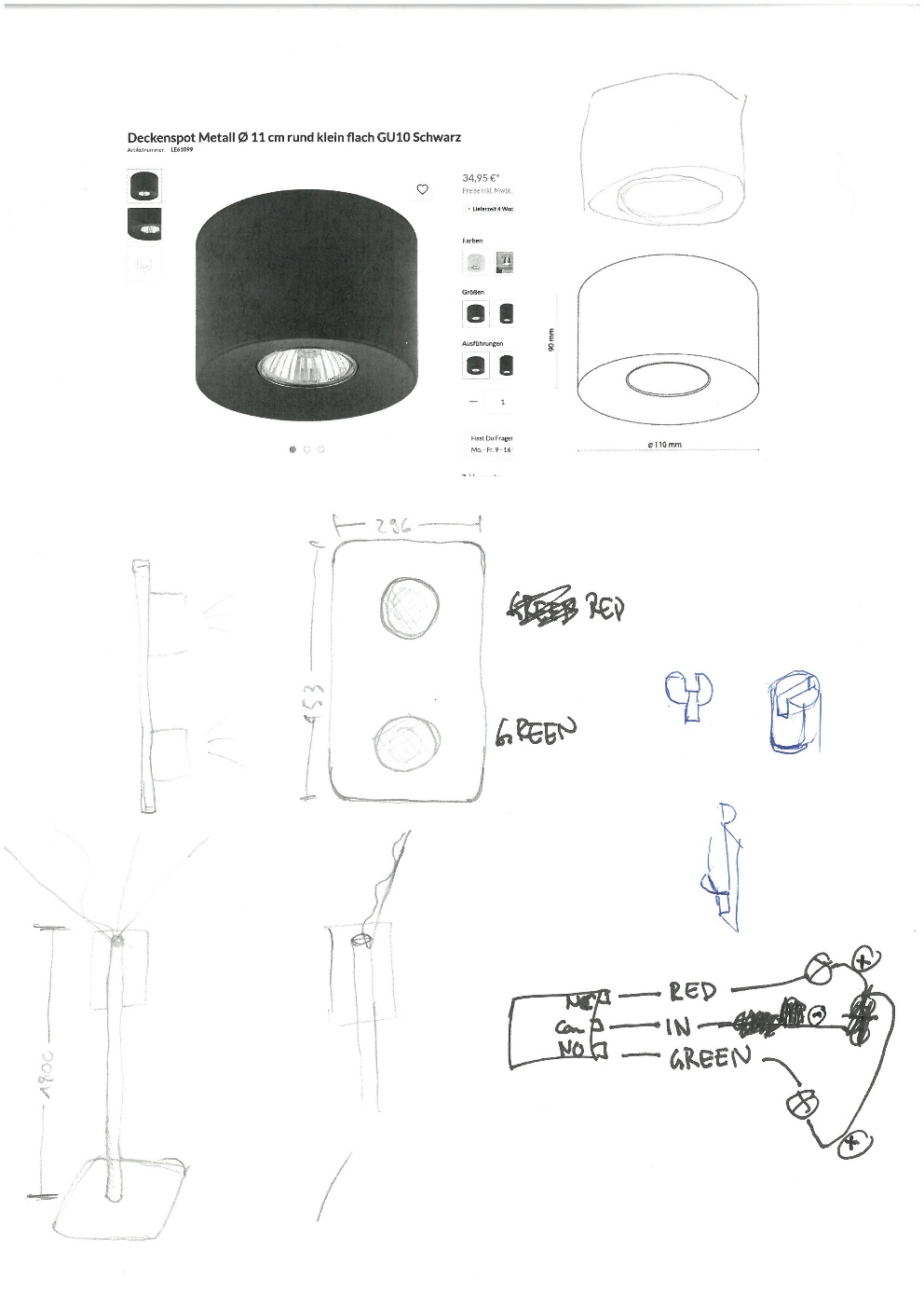
Spots: GU10 schwarz – Paulmann EBL Choose 3er Spot starr max 3x10W 230V 51mm Schwarz matt Alu
Electronics:
- 12V Source
- Relais: Joy-it KY-019 Relais Modul
- Controller:
- Development board:

